Step 1. Get Pyenv

<https://github.com/pyenv-win/pyenv-win>

Step 2. Install Notepad ++

Step 3. Open Windows PowerShell

Type “pwd” to print working directory

Create a python project directory wherever you desire

Cd to that directory



Step 4. Set up Pyenv using tutorial above

Check the version of python you’re using



Step 5. Write your .py script using notepad ++ in your working directory

Step 6. To run a script, python “name of file.py”

Step 7. Where are my virtual environments and how do I open them?

First, navigate your working directory to your project file

Then, type dir:

My virtual environment is called ruwebscrape. I then open that virtual environment:



You can tell I opened it because it has the name of my virtual environment in green

Starting a new project (you don’t need to change the global env version unless you really want to)

# In order to change the global env version

See what options are available first



Install the version you want



Then set it as your global version



# In order to set up local environment

Navigate to the directory you want (in thie example we use liam-playground)

# Create a virtual environment for the project



Enter the venv



You’ll get this:



To leave the venv:



Nice job! 😊

This is how you see what is written in python-version:



When creating a new project, you want to choose the version of python

Other notes: The thing that you actually write code in is called an Integrated Development Environment (IDE). The most basic one is called IDLE for Python.

OK, now I have python! How do I code?

Well, one of the easiest ways is to use IDLE. If you have Python already installed on your computer, a simple search should bring it up. It is built into Python.

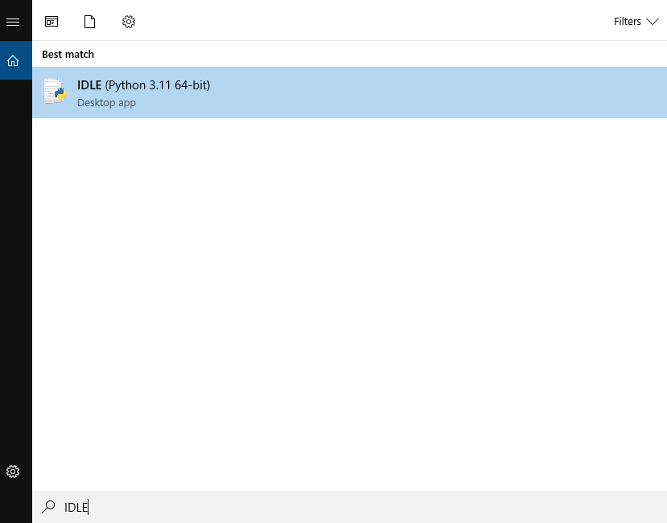

When you open it, it should look like this.

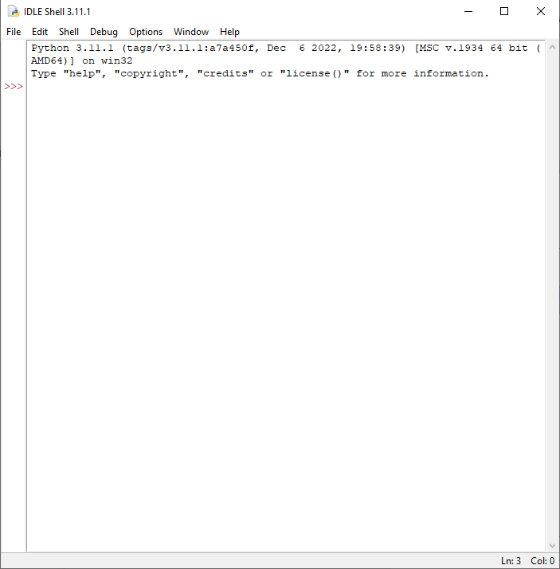

Try something!

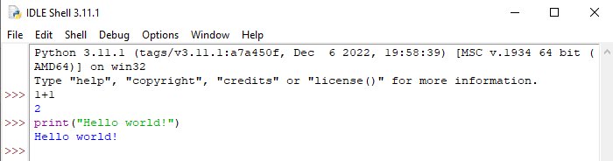

It works! How else can you do the same thing?

Search for “powershell”

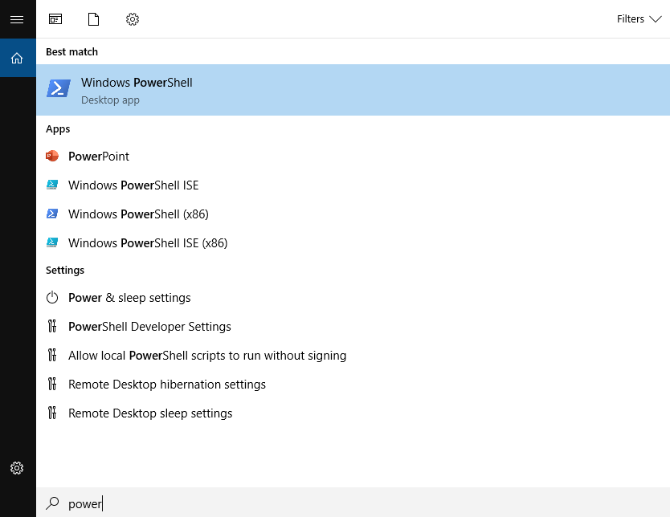

Open it… you get an intimidating looking blue screen…

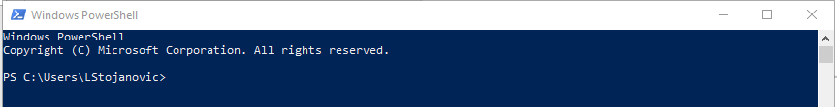

You can follow powershell directions above. You can navigate to your project directory like this.

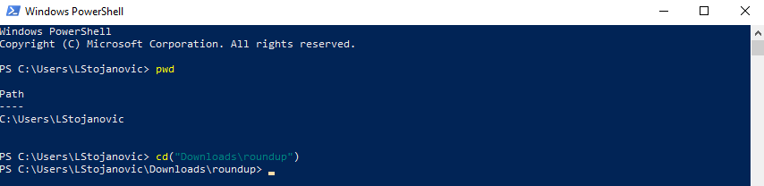

You can use “dir” to see if you already have a venv set up.

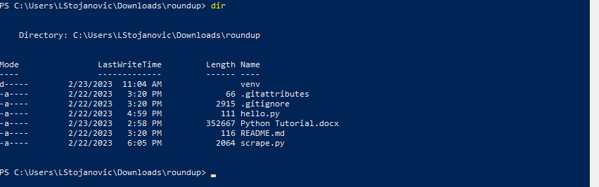

Look – I do have a venv!

What if you don’t have one and want to set one up? Let me show you with a new directory. It’s empty. It’s called “test_directory”



Here’s [more info on venv](https://docs.python.org/3/library/venv.html). As far as I can tell, it comes with Python. No need to install any packages.

To make a new venv type:

python3 -m venv /path/to/new/virtual/environment

so in this case, since I am already in the desired venv directory, I’ll make the /path/to/new/venv/ just the following: venv

(This is standard practice.)

Don’t worry if it’s a bit slow to run, that is expected.

The directions from above apply:



Enter the venv



You’ll get this:



To leave the venv:



Nice job! 😊

What if you want to open IDLE from the venv? Here’s a [helpful stackoverflow](https://stackoverflow.com/questions/4924068/how-to-launch-python-idle-from-a-virtual-environment-virtualenv#:~:text=After%20running%20the%20IDLE%2C%20you,using%20ctrl%2Bo%20keyboard%20shortcut.&text=Save%20this%20answer.,-Show%20activity%20on) where I got the answer from:

Step 1. Open the venv.

Step 2: run the following: python -m idlelib.idle

e.g.



Wow!

How do we know that worked?

Follow these directions to install packages in a virtual environment. (Based in part upon [this](https://packaging.python.org/en/latest/guides/installing-using-pip-and-virtual-environments/) link.)

Open your directory in question and your venv.

Then run the following: python.exe -m pip install --upgrade pip (you only need to do this once)

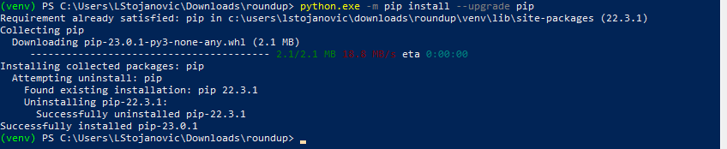

You can check what version you have:

python -m pip --version



Cool!

1. Activate your virtual environment (below instructions are based in part on [this](https://packaging.python.org/en/latest/guides/installing-using-pip-and-virtual-environments/) link)
2. Check you have pip using python -m pip –version

If pip is installed in a path within your venv, that is a good sign!

1. Install the package.

py -m pip install requests

in this case, the package is called “requests”

Steps 2 and 3 are shown below.

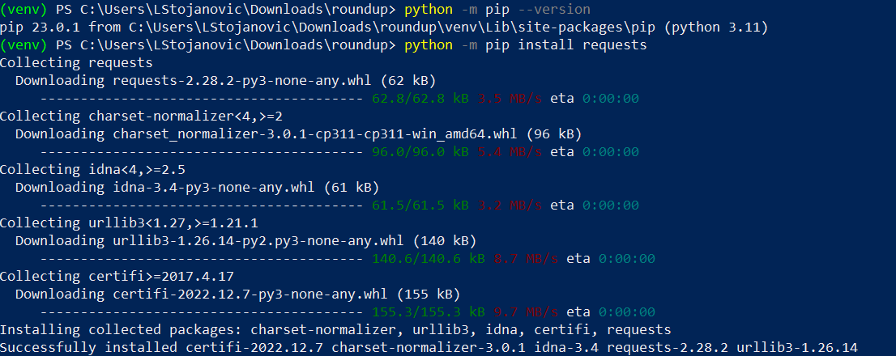

You can do this to successfully install packages! Try installing a few that you think you’ll need. Then come back to this guide. I will show you how to check that they have been properly loaded into your computer.

Check this out! What packages have I installed? To see, type in the following code:

python -m pip list

wow! Look at all those packages! Note that you can use instructions linked [here](https://docs.python.org/3/tutorial/venv.html#managing-packages-with-pip) to download specific versions of packages that aren’t the most recent ones, if you want.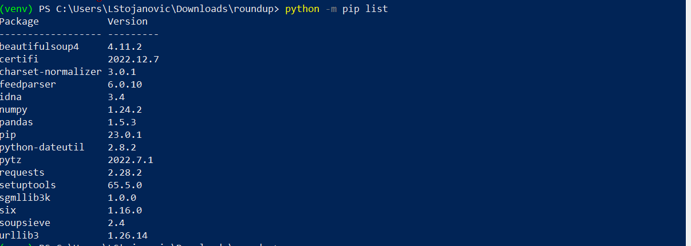

Let’s now try creating our first ever requirement.txt file. This is essential for sharing our work with others. Packages are very big, and come with many versions. Sometimes, when packages are updated, old code that we wrote based on the packages can break (the ability for a script to continue to work over time despite these changes is called “backward compatibility”). The issue of backward compatibility is one reason we use virtual environments. Virtual environments preserve the packages exactly as they were when we used them. Note that virtual environments do *not* preserve individual versions of Python. That is something that pyenv does.

But before that, a note on uninstalling packages from https://pip.pypa.io/en/latest/user_guide/#requirements-files :

**Uninstalling Packages**

pip is able to uninstall most packages like so:

py -m pip uninstall SomePackage

pip also performs an automatic uninstall of an old version of a package before upgrading to a newer version.

**What is a requirements.txt file?**

A requirements.txt file is an excellent resource for code replicability and sharing. It’s a simple text file listing of all the packages and versions of those packages that your project uses. Making one is very simple. And using one to load packages is also simple.

**Why use a requirements.txt file? Why not just share the whole virtual environment with someone else?**

Good question. I don’t exactly know all the details, so if you want to know why, you might need to do more reading. If a simple answer will suffice, there are two main reasons that I understand:

1. Virtual environments have a lot of data and files. Uploading them and downloading them repeatedly is very impractical.
2. Virtual environments are configured somehow specifically for your computer. If you try to just send someone else your venv directory, it probably wouldn’t work properly on their computer, anyway!

**Ok, I understand why I shouldn’t upload and download my venv constantly. But how do I stop git from doing this for me?**

Good thing you asked. You can create a special type of file called .gitignore

I know that “.gitignore” seems like a scary file extension, but don’t worry! It’s also just a text file at heart. Here’s the current .gitignore file associated with the roundup project as it stands:

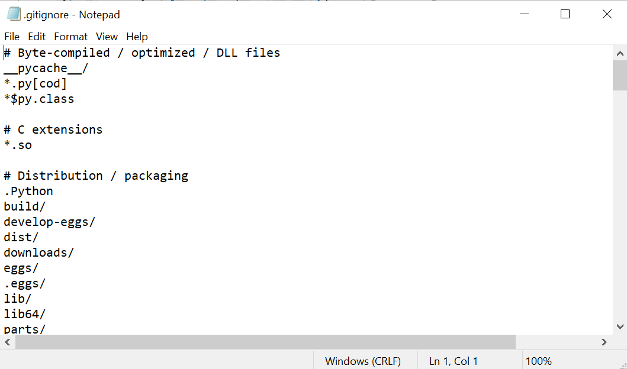

I haven’t scrolled all the way down. There’s more stuff at the bottom, that you might actually recognize:

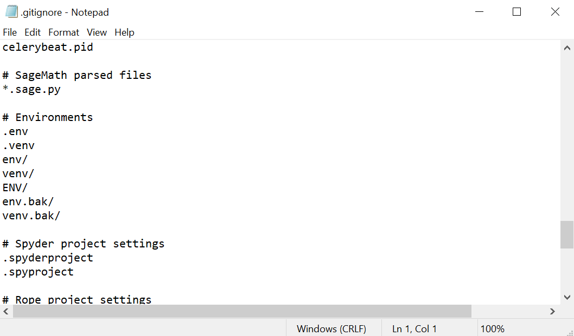

See the environments section? It’s telling github that every time it uploads a file, it should ignore (i.e., not upload, download, or touch in any way) the files or directories starting with this extension. You can see “venv/” is on this list. Our virtual environment is safe from being uploaded and downloaded – a good sign.

How did I make this file? It was simple. Let me show you the step-by-step process, so that if you ever create your own project directory, you know what to do.

1. Open your Github for desktop app. Here’s what mine looks like:

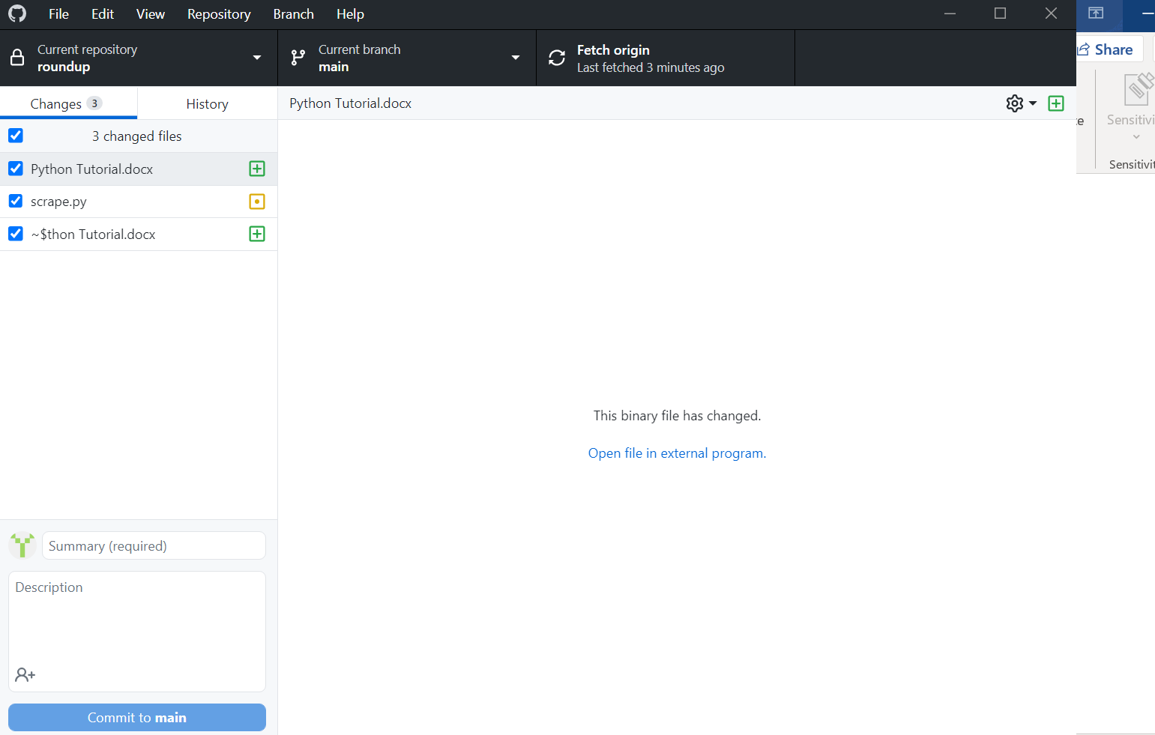

1. Click “File > New repository”

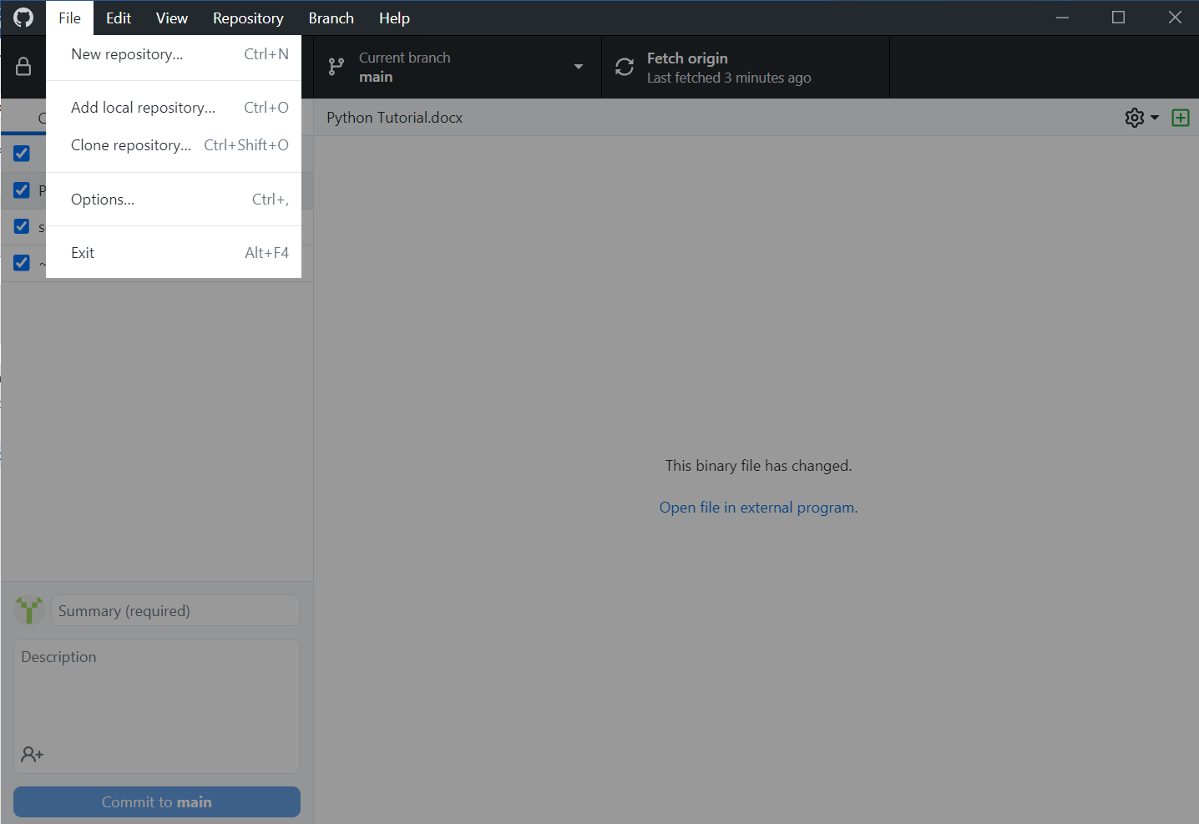

1. Give your repository a funky name and choose a file path. Add a fun description if you’d like!

Note on the file path: You can save your directory anywhere on your computer that you like. However, if that location on your computer is already covered by a cloud service like OneDrive, SharePoint, or Google Drive, you might run into some issues. These services already do something similar to GitHub: They save directories to the cloud for easy storage and backup. Because of this, they may override the changes that GitHub makes. Say, for example, you save a file locally on your computer in the example_repo. Then, you decide to push that change to the origin version of the file. Then it might be the case that SharePoint will locally override your changes by syncing. (I don’t know exactly how this works. It’s never happened to me, but I’ve been warned by Nasiha.) Anyway, just don’t do it.

My repo (aka directory, aka folder) is saved in the “Downloads” folder in my computer. Cringey, I know! But that is one of the few areas of this computer that is not covered by a cloud syncing service.

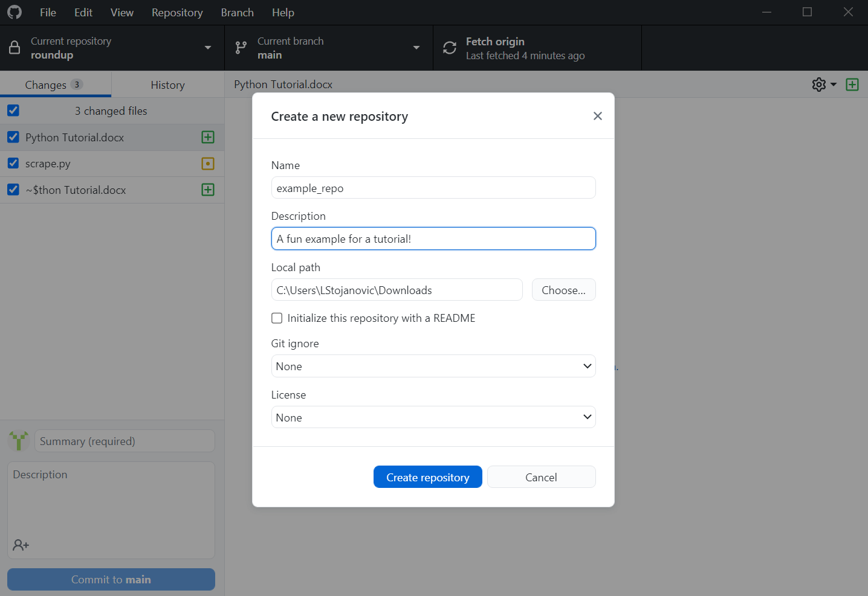

1. The important step!!! See the setting called Git ignore? Select an item from the drop-down list. I don’t know exactly what the list means. I’ve tried Googling it, to no avail. But I figure it provides some examples of useful Git ignore files depending on the coding language you are using.

Don’t fret if you are confused! Just choose the “Python” version.

The .gitignore file is just a text file at heart. If you ever want to edit it, just use an application like Notepad to open it. For our purposes, I think the only line of code you’ll need in it is one that says

venv/

But I do appreciate that they have fancy versions already set up. It looks like they even have versions pre-set for R.

Anyway, as long as you set that up when you create your repository, you are good to go.

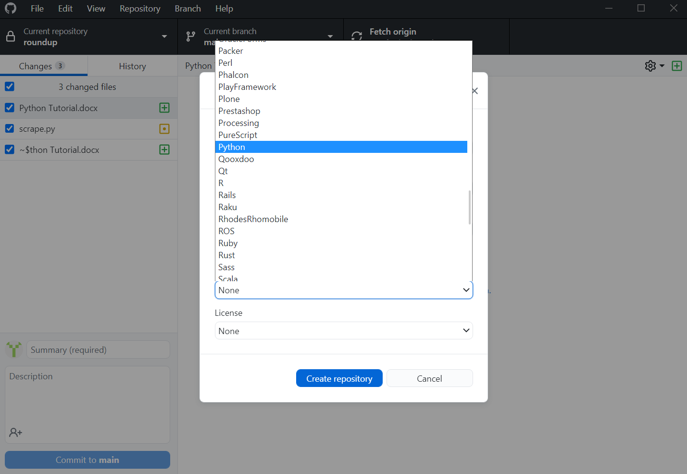

1. Here’s a screenshot of my file explorer, just to show you the result. Github created the folder where I told it to, and also put a file in it called “.gitignore”, just like in the other example. Yay, yay, yay!

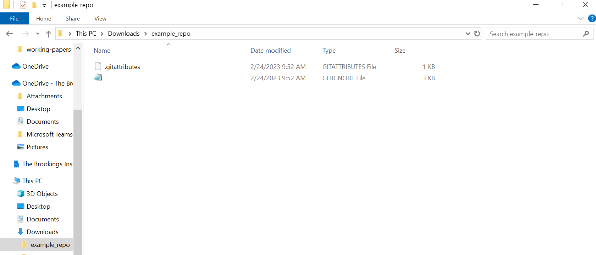

If you need to output your requirement.txt, use the resource below.

This is useful if you are tracking your project with git and need to share it with someone else.

<https://pip.pypa.io/en/latest/user_guide/#requirements-files>

[12. Virtual Environments and Packages — Python 3.11.0 documentation](https://docs.python.org/3/tutorial/venv.html#managing-packages-with-pip)

Try using this too

<https://stackoverflow.com/questions/31684375/automatically-create-requirements-txt>

and this

<https://pip.pypa.io/en/latest/user_guide/#requirements-files>